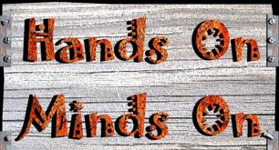
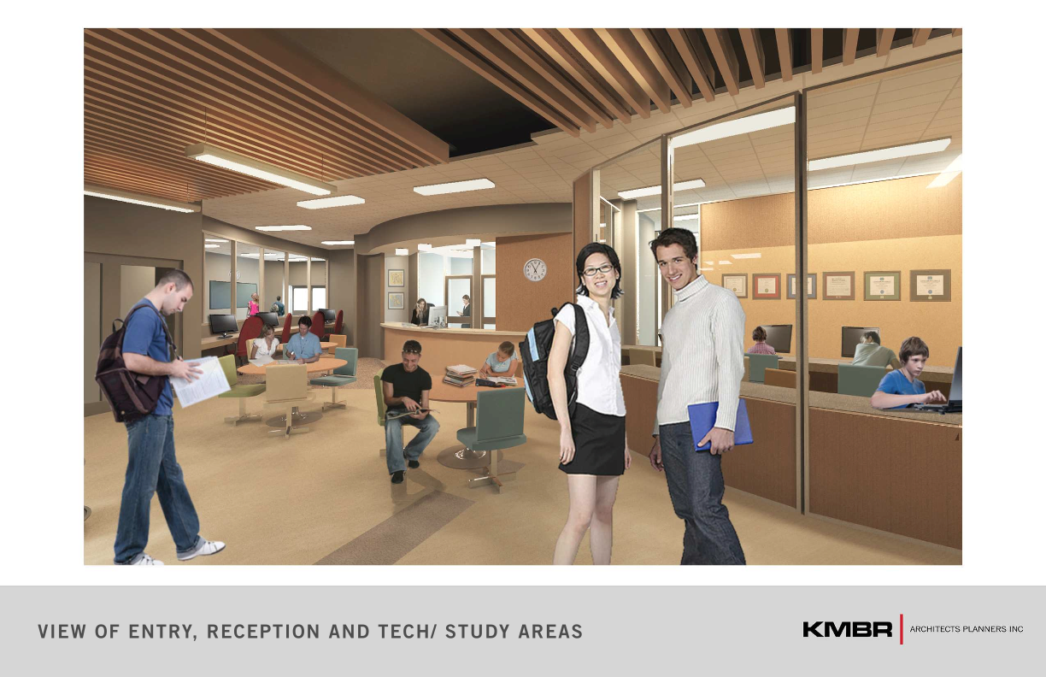
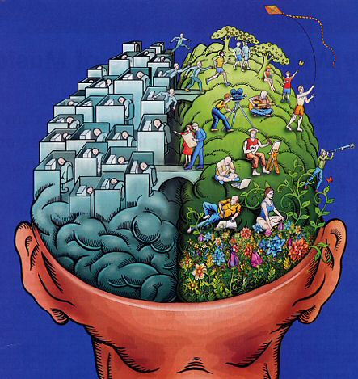
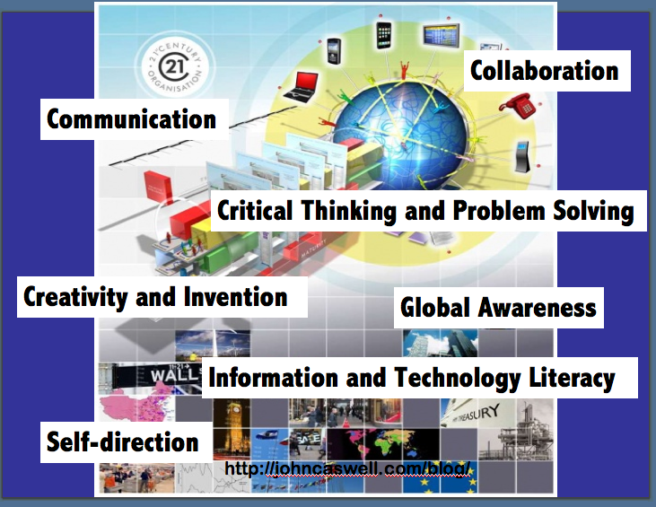
We know so much about how humans learn!

Education’s big goal, preparing students to contribute to the world of work and civic life, has become one of the country’s biggest challenges. In fact, all the other great problems of our times – solving global warming, curing diseases, ending poverty, and the rest – don’t stand a chance without education preparing each citizen to play a part in helping to solve our collective problems. Learning for work and life in our times means helping as many people as possible learn to apply 21st century skills and solid understanding of core subjects to the challenges of our times. A 21st century education for every child is the first challenge - the one that will enable all our challenges to be met.
~B. Trilling and C. Fadel

ELC
Energetic Learning Campus
www.prn.bc.ca/elc

pr

PBL
Project Based Learning

21st Century Skills

Schools tend to:
- Separate kids based on ability
- Separate hands from minds
- Separate kids from the world beyond

ELC and PBL will:
- Integrate students
- Integrate subjects
- Integrate the world beyond

“If we teach today as we taught yesterday we rob our children of tomorrow.”
 
- It is a social process
- Motivation is key
- Each learner brings different knowledge to the table
- Each learner starts from a different place
- Each learner follows a different route to the same place

Knowledge should be discovered as an authentic and integrated whole!

21st Century Skills

Q&A

Energetic Learning Campus
What will ELC offer?
Personalization: ELC will foster student engagement by knowing students well, tapping into student experience and interests, and building a strong sense of community.
- small learning community (200 grade 10’s)
- advisory program for all students
- projects reflect students’ interests and passions
- integrated support services for students with needs
- personal reflection as an explicit academic routine

Adult World Connection: All students will engage in community-based learning, collaborating with adults on meaningful work that extends beyond the school walls.
- Students participate in field studies and other community based learning
- Student projects contribute to the workplace or community
- Students regularly exhibit their work to authentic adult audiences

Teacher as Designer: Teachers work in interdisciplinary teams to develop curriculum and programs.
- Curriculum is designed by teacher teams
- Teachers meet weekly in teams for planning and staff development
- Teachers participate in healthy living activities
- School district provides teacher resources and support for learning

Typical Days (a tentative picture)
Monday
8:45-9:00 Advisory group – set weekly/daily goals
9:00–9:45 Physical activity – swim, walk, run, skate, gym, yoga, etc…
9:45–10:00 Nutrition break/health seminars
10:00–11:00 Math
11:00–12:00 Project work
12:00 12:45 Lunch
12:45– 1:45 Humanities
1:50–3:00 Project work/collaboration

Tuesday
8:45-9:00 Advisory group – set weekly/daily goals
9:00–9:45 Physical activity – swim, walk, run, skate, gym, yoga, etc…
9:45–10:00 Nutrition break/health seminars
10:00–11:00 IT/work/collaboration
11:00–12:00 Science
12:00 12:45 Lunch
12:45– 1:45 Humanities
1:50–3:00 Project work/collaboration/advisory group

Students will receive 8 courses (4 credits each):
Math, Science, English, Social Studies, Planning, PE and two of the following:
Digital Media, Art, Leadership or Super-fit.
A PBL Hockey Academy will be offered to some Grade 10’s.
What is PBL?
Project Based Learning (PBL), rigorous projects are carefully planned, managed, and assessed to help students learn key academic content, practice 21st Century Skills (i.e. collaboration, communication & critical thinking), and create high quality, authentic products & presentations.

What electives will be offered?
Grade 10 students will be offered 2 electives at NPSS. ELC will offer Digital Media 11, Art 10, Leadership, and Super-fit. Shop classes will not be offered but the Digital Media 11 course will meet your grade 11 fine arts/applied skill requirements for Grad and this will leave room for you to take those shop classes you may miss in grade 10 at ELC.
What about NPSS sports teams?
ELC students will participate on NPSS sports teams.
What about specialty courses?
Second Languages, Band, and Musical Theatre will not be offered in the first year of operation.
For more Q&A go to:
www.prn.bc.ca/elc

